2016-2019

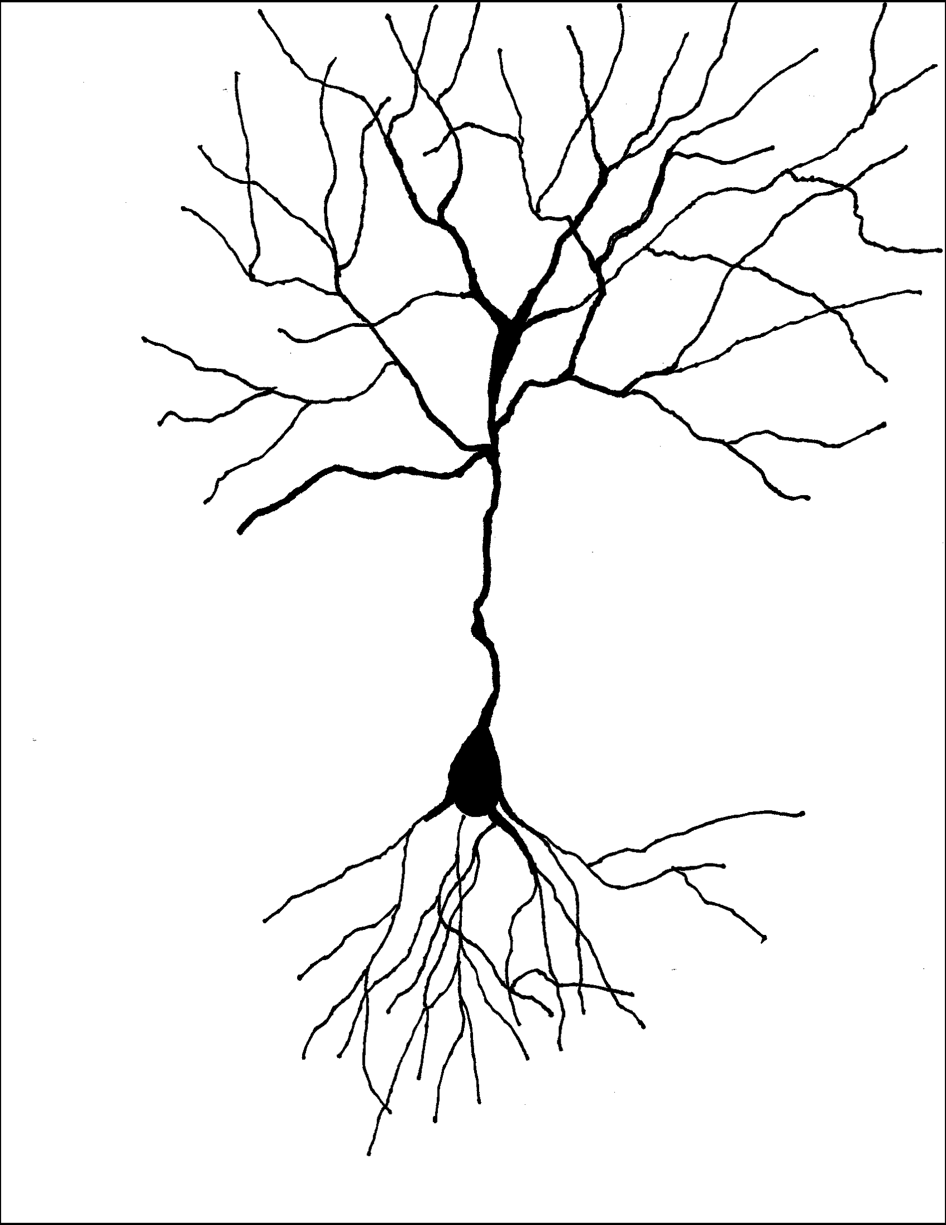

AIG
Parent
Handbook

Chatham County Schools
Academically or Intellectually Gifted Program

www.chatham.k12.nc.us
Contact your school AIG specialist
for referral information.

Chatham County Schools
Academically or Intellectually Gifted Program
Vision Statement

Through collaboration with students, parents, guardians, faulty and administration, CCS AIG will enhance the academic and social/emotional lives of students to promote success in life.

Article 9B. Academically or
Intellectually Gifted Students

§ 115C-150.5. Academically or intellectually gifted students.

The General Assembly believes the public schools should challenge all students to aim for academic excellence and that academically or intellectually gifted students perform or show the potential to perform at substantially high levels of accomplishment when compared with others of their age, experience, or environment. Academically or intellectually gifted students exhibit high performance capability in intellectual areas, specific academic fields, or in both intellectual areas and specific academic fields. Academically or intellectually gifted students require differentiated educational services beyond those ordinarily provided by the regular educational program. Outstanding abilities are present in students from all cultural groups, across all economic strata, and in all areas of human endeavor.

(1996, 2nd Ex. Sess., c. 18, s. 18.24(f).)

Table of Contents

Referral Information
Placement Information
Service Options
Social/Emotional Needs
Transitions
Communications
Policies and Procedures
Glossary

Referral Information

First Steps
The evaluation process is rigorous and requires time out of the classroom’s regular instruction. Students will be working with the AIG specialist and possibly an AIG specialist from another school for the evaluation.
Ask: Is your child ready for this? Can he/she miss classroom activities and be comfortable?
Next: consider the criteria in this brochure. Compare your child to the criteria. Use typical milestones for this. One example is an early reader isn’t necessarily gifted, but an early reader showing great comprehension might be. Talk with your classroom teacher or the AIG specialist objective input.
Ask: Does your child fit these criteria?
Next: get a referral form/permission to evaluate form from the office at your school or the AIG specialist. You can also download and print one from the website. Return this to your school’s specialist.

Second Graders
Only second grade transfer students who are identified in a previous school* are placed in the AIG program. Evaluation of students in the second grade invalidates test scores in the third grade. Third graders are screened and tested with tests that can only be administered once during a calendar year. Second graders are served by differentiation within the classroom.

Kindergarteners & First Graders
These students can be evaluated. Be aware that they may only be placed if they are Highly Gifted. Students in the HG range are exceptionally gifted and in the top 2% of all students academically. Some students are not ready for the evaluation process but are ready at third grade. It is exciting to watch them grow into success.

Pathway 1: Grades 3-12
Students must meet four criteria in reading or four in math to receive gifted education services in reading and/or math. Not all criteria must be included in evaluation. Students scoring at the 98th percentile on an accepted aptitude and/or the achievement test and have one other criteria met are automatically placed in the AIG program as Highly Gifted in the area(s) of qualification. Highly Gifted in both math and reading places a student as AI. Additional data is not necessary for placement.

Available criteria include:
- ≥90th percentile Aptitude testing.
- ≥90th percentile Achievement testing.
  - ≥90th percentile SMI testing may be used for math achievement as an example.
- ≥80% on AIG Portfolio scored on AIG rubric demonstrating work at least one grade level above the current grade level. (May be in native language or English.)
- Growth - Based on WIDA, a second language evaluation tool, scores as outlined from consultation with ESL Department.
- ≥90th percentile using accepted tests in areas outlined in this plan may be submitted by parents/guardians. These tests and reports must be conducted and written by a private, licensed psychologist or psychiatrist with a school related focus. The entirety of the report must be presented to the Needs Determination Team. Psychological reports must be submitted in full and will be considered in full for the best educational placement of the student. CCS is not responsible for providing outside testing.
- ≥80% on the AIG Specialist Inventory (based on multiple sources from current research).
- ≥80% on the Research Checklist for reading and/or math (currently the Scales for Rating the Behavioral Characteristics of Superior Students which is also known as Renzulli Scales).
- ≥80% on optional, student choice portfolio submission scored on AIG rubric. Submission must have been accomplished at school with minimum assistance by teachers.
- ≥80% on one of the Renzulli areas of Creativity, Communication, Learning, Leadership. Only one of these areas may be used as a qualifying criteria.
- Highest 5% (within the school) on a nationally normed standardized test that allows for demonstrated understanding of mathematics above the current grade. (For example, SMI.)
- Highest 5% (within the school) on a nationally normed standardized test that allows for demonstrated understanding of reading comprehension above the current grade.

Pathway 2: K-1
Students scoring at the 98th percentile on an accepted aptitude, or achievement test and have one other criteria met are automatically placed in the AIG program as Highly Gifted in the area(s) of qualification. Additional data is not necessary for placement. Not all criteria must be included in evaluation.

Available criteria include:
- One of the following is required:
  - ≥98th percentile on one or more batteries of a standardized aptitude test in reading or math.
  - ≥98th percentile on one or more batteries of a standardized achievement test in reading or math.
- ≥90% on AIG Portfolio scored on AIG rubric demonstrating work two grade levels above the current grade level.
- ≥98th percentile using accepted tests in areas outlined in this plan may be submitted by parents/guardians. These tests and reports must be conducted and written by a private, licensed psychologist or psychiatrist with a school related focus. The entirety of the report must be presented to the Needs Determination Team. Psychological reports must be submitted in full and will be considered in full for the best educational placement of the student. CCS is not responsible for providing outside testing.
- ≥80% on the AIG Specialist Inventory (based on multiple sources from current research).
- ≥80% on the Research Checklist for reading and/or math (currently the Scales for Rating the Behavioral Characteristics of Superior Students which is also known as Renzulli Scales).
- Highest 2% (within the school) on a nationally normed standardized test showing demonstrated understanding 2 years or above the current grade in Reading comprehension.
- Highest 2% (within the school) on a nationally normed standardized test showing demonstrated understanding of mathematics 2 years or above the current grade.

Students placed in K-1 are considered Highly Gifted, AI if both reading and math meet the Highly Gifted standard, or IG.

Service Options

General Service Options
- Differentiation = Differentiation means tailoring instruction to meet individual needs. Teachers may differentiate content, process, products, or the learning environment. Differentiation is developed based on ongoing assessment. Differentiation, by its nature, is different for different students and different for individual students at different points in the curriculum.
- Flexible grouping = Groups that change for a variety of learning experiences. Some students may be in a group that needs to learn a specific concept. Those same students may be in another group needing more challenging material for another concept.
- Grouping = Placement of at least five AIG students within a class. This allows the teacher to focus on the needs of AIG students more easily. Principals make class roster decisions.
- Content acceleration = Material ahead of the student’s current curriculum grade level is taught. The materials follow the lines of the NC Standard Course of Study.
- Curriculum compacting = This option allows students to demonstrate mastery of upcoming content in order to focus on topics relevant to their interests. Clear structures must be agreed upon and put in place for this option.
- Interest groups = These may take the form of literature circles in which students choose books, self-selected extra-curricular activities, clubs, problem based learning opportunities, science fair experiments, and other optional teacher or student created investigations.
- Specialized projects = Here students may work on specific problems or research. A huge variety of possibilities exist for this.
- Specialized materials = Teachers and specialists have access to many types of advanced and creative materials. Depending on the area(s) of identification, more challenging reading selections, spatial math investigations, or problem-solving materials.
- Consultation = Students remain in the regular classroom but are monitored by the AIG specialist. Teachers, may, of course, request curriculum or other resources for these students. In general this option is used when students have gaps in learning or are experiencing significant difficulty in grade level concepts.

Social/Emotional Needs

Dr. Rick Courtwright of Duke TIP says, “Gifted students are often just more gifted in many areas.” He includes social and emotional needs in those many areas. Gifted students are no more prone to having needs than any other group of students. However, their needs can be profoundly different and intense.

CCS wants to assist each child in the best possible way. If you or your child need assistance in this area, we are ready to help. Grade level does not matter. Let your specialist know your concerns. AIG will work with classroom teachers and guidance counselors to find the best solutions within the school system.

Some of the issues you may encounter include:
- Perfectionism
- Intensity
- Loneliness
- Frustration
- Apathy
- Lack of organizational skills
- Arguing
Communications

Publicity for referral times and events is delivered through print, phone calls from principals and announcements. One of the prime events is called Parent University. This series has topics of interest for every parent but an emphasis on parents and sometimes gifted children. You will get notices for Parent University by phone calls and emails.

Every student receives a DEP/IDEP for the coming year. These plans include the differentiation that should occur
across the grade level. More may take place but these are the basic steps teachers will take to give your child the services he/she needs.

End of year reports are sent home each year. These will include student set goals and self-evaluations, reminders of qualifications for the program and a reminder of your child’s area(s) of identification.

Transitions

The AIG program varies as students progress in their careers. An overview may help you and your child see the differences.

K-3 Nurture: Students are chosen through criteria for talent development according to the school’s makeup. AIG identified
students are served in the regular classroom by the classroom teacher. AIG specialists may support the classroom teacher by supplying or creating curriculum.

Grades 4-5: Students are pulled out of regular classes more often and by area of giftedness. Work may be done using problem-solving strategies or Genius Hour. Both serve to anchor higher level activities.

Middle Grades: A combination of pull out and push in are seen in these grades. Skills are targeted using higher level materials. Push in allows specialists to assist with thinking skills in the classroom.

High School: Students may choose to take advanced courses, honors classes, AP classes, online classes, and early college classes.

When a student is placed in AIG, the student is always labeled as AIG. Note the service options may change at any time as decided by the NDT.

Policies and Procedures

Procedure to Resolve Disagreement:
Should a disagreement occur, CCS provides this process to resolve disagreements related to improper placement of the child in the AIG Program or improper implementation of the CCS AIG Plan as relates to the child.

- School Level
The parent/guardian may appeal by submitting a written grievance stating reasons for the disagreement with the placement or service option presented. Written information must be submitted to the school principal within 30 calendar days. The principal or his/her designee will investigate and reply in writing generally within 10 business days.

- Administrative Levels
    - If no resolution is reached at the school level, the parent/guardian may appeal in writing to the Chatham County Schools Exceptional Children’s & AIG Programs Department within five business days of the receipt of the principal’s decision. Written information must be sent to the Executive Director of Exceptional Children’s and AIG Programs, P.O. Box 128, Pittsboro, NC 23712. Generally responses can be expected within 10 business days.
    - If no resolution is reached at the departmental level, the parent/guardian may appeal in writing to the Chatham County Schools Assistant Superintendent for Academic Services and Instructional Support within five business days of the receipt of the department’s decision. Written information must be sent to the Chatham County Schools Assistant Superintendent for Academic Services and Instructional Support, P.O. Box 128, Pittsboro, NC 23712. Generally responses can be expected within 10 business days.
    - If no resolution is reached at the Assistant Superintendent’s level, the parent/guardian may appeal in writing to the Chatham County Schools Superintendent within five business days of the receipt of the Assistant Superintendent’s decision. Written information must be sent to the Chatham County Schools Superintendent, P.O. Box 128, Pittsboro, NC 23712. Generally responses can be expected within 10 business days.

- Board of Education
If no resolution is reached at the administrative level, further written appeal may be submitted to the Chatham County Board of Education following Board procedures. These procedures are outlined in CCS Policy 1740-4010.

- If no resolution is reached at this level, the parent/guardian may seek mediation or file a petition for a hearing under Article 3 of Chapter 150B of the NC General Statutes. The decision of the administrative law judge is final.

CCS Board Policy Related to Acceleration
3420 Regulation Regarding Promotion and Accountability
Grade Acceleration

To determine the eligibility of a student to move to a higher grade level than the current enrollment, the principal shall confer with a committee of professional educators to consider the following factors:

- Student Aptitude. The child shall be highly advanced in academic and social development and shall score at the 98th percentile on specified standard individual test(s) of intelligence administered by a licensed psychologist or psychiatrist. The most recent edition of the specified test(s) shall be used. Testing must have occurred less than one calendar year prior to proposed advancement.
- Achievement. The child shall be functioning from two to three years beyond the child’s peers. The child shall score at the 98th percentile on both reading and mathematics on specified standard individual test(s) of achievement. Results must be less than one calendar year old.
- Performance. The child shall be able to perform tasks well above age peers as evidenced by behaviors in all areas such as independent reading, problem-solving skills, advanced vocabulary, and writing fluency.
- Observable Student Behavior/Student Interest and Motivation. The principal or principal’s designee shall conduct an interview with the child and a more structured interview with the parent to determine if the child is able to successfully move to the new grade level.
- Completion of the Iowa Acceleration Scale, the most current edition, shall be accomplished to assist the principal in making an informed decision regarding the promotion. An AIG specialist will manage the completion process.
- After considering all factors, including input from the committee, the principal shall decide whether to grant the request for enrollment within four weeks after receiving all information. If the principal determines that the child has not adjusted to the grade level setting, the principal shall retain the right to reverse enrollment from the now current grade level to the original grade level.
- Parents may be required to supply information in addition to that required by this policy.
- Decisions related to early admission to kindergarten shall be made pursuant to applicable state board policy.

Chatham County Schools will not conduct testing for grade acceleration.

Accepted tests include: CogAT, ERB, and Iowa Assessments. ACT and SAT scores may be considered at the discretion of the district administrator who oversees the AIG Department. The administered level of the CogAT shall be two grade levels above the student’s current grade.

Chatham County Schools may require parents to supply information in addition to that required by this policy and may also require specific tests or other measures to provide information relating to the factors listed in this policy.

Chatham County Schools will not conduct testing for Early Admission to Kindergarten.

AIG Plan Glossary 2016-19 (Abbreviated)
21st Century Content/Skills | Examples include: presenting your work to a group, developing a world view, analyzing data.
2e | Twice-exceptional
Acceleration | Moving ahead of peers in content or in grade level. Often called "grade skipping" if moving up a grade.
Acute circumstances | Circumstances that may affect the demonstration of student abilities. Examples include but are not limited to ongoing poverty, poor home situation or illness.
Advanced Learner | A student who learns content very quickly or exhibits knowledge ahead of peers but is not identified as AIG.
Advisory Board | A group of persons interested in and impacted by the AIG Program. The group assists in evaluating implementation and new plan construction.
Affective | Social or emotional qualities.
AG | Academically gifted in both Math and Reading.
AI | Placed as highly gifted intellectually and highly gifted in BOTH reading and math with a ≥98th percentile score on accepted aptitude test in reading comprehension and math.
AIG | Academically or Intellectually Gifted.
AM | Academically gifted in Math.
AR | Academically gifted in Reading.
Area of Identification | Math or Reading or both.
Battery Scores | Scores for the major groups of small tests within standardized tests.
CCS | Chatham County Schools.
CCSNDT/CCS Needs Determination Team | The placement or identification team for the CCS. This group makes the final placement decisions.
CogAT | Cognitive Abilities Test - an abilities or aptitude test currently used by Chatham County Schools as an evaluation tool.
Criteria | Qualities that may be considered when making a placement decision.
DEP | Differentiated Education Plan for gifted students.
Differentiation | Tailoring learning options and strategies to best serve students at whatever level of readiness, skill, ability, maturity, and affective need they are.
EC | Program for students with unique needs. These students are designated thusly through the Exceptional Children's Department.
EL | English Learners. Students who are in the ESL Program.
EOC | End of Course test.
EOG | End of Grade test.
ESL | Program for teaching English as a Second Language.
Exceptional Children | Students with unique needs. These students are designated thusly through the Exceptional Children's Department. EC
Genius Hour | Time when students are focused on their choice of topics and methods. Developed in cooperation with teachers.
Grade skipping | Moving ahead a grade level from the currently enrolled or anticipated enrollment grade level.
HG | Highly gifted: Highly gifted in either reading or math with ≥98th percentile score on accepted tests in reading comprehension or math with one other criteria met.
Identified | Placed in the AIG program within one of the state AIG categories.
IDEP | Individual Differentiated Education Plan for gifted students with a unique educational need.
IEP | Individual Education Plan for exceptional child.
IG | Highly gifted intellectually in both reading and math with ≥98th percentile score on accepted tests in reading comprehension and math with one other criteria met.
Inventory | List of student behaviors that may indicate giftedness.
Needs Determination Team or NDT | Team at the school that makes recommendations regarding identification of students.
Nurture | Cultivating potential in students. Designed for non-identified students.
Parent University | Presentations for the community regarding students and topics that impact families and education. While aimed at gifted students' parents usually, the presentations most often apply to every parent.
Pathways | Qualifying criteria and method for placement.
Placement | Identification of a student and participation in the AIG program.
Portfolio | 1. Student chosen example of his/her work completed within the school environment. 2. Series of tasks our county uses to add to evaluation data.
Problem-based Learning Units | A real world problem is presented. Students develop the approaches to solving the problem. Students are given specific roles in the problem solving. Teams may be used. Research is done by students. Answers or solutions are presented to an interested audience.
Pull Out | Working with students in a separate location for instruction.
Push In | Working with students in their classroom.
Referral | Submission of a student name for evaluation for placement in the AIG Program.
Screening | Mass testing of students
Service Options | General types of differentiation within which different strategies may be used.
Specialist | An educator who works with particular subjects or student groups.
Student Driven Learning | Students decide on how and sometimes what they will learn. Students work with teachers to define the expectations for these situations. This type of learning is proven to be relevant, ultimately related to the curriculum skills, and enthusiastically done.
Subtest | Major groups within standardized tests.
Summative Assessment | An assessment given after content is covered to determine the new level of mastery.
Transfer Student | A student coming in from another county, state, or alternative school.
Twice-exceptional | Gifted with some type of exceptionality such as a learning disability. 2e
Typical Gifted Behaviors | Students demonstrate abilities through such means as high performance, curiosity, pleasing behaviors, self-motivation and perfectionism.
WIDA | Group that designs tests for English Language Learners. The testing is called ACCESS.

