Pathway 1: Grades 3-12 (cont’d)  - submission scored on AIG rubric. Submission must have been accomplished at school with minimum assistance by teachers.  - ≥80% on one of the Renzulli areas of Creativity, Communication, Learning, Leadership. Only one of these areas may be used as a qualifying criteria.  - Highest 5% (within the school) on a nationally normed standardized test that allows for demonstrated understanding of mathematics above the current grade. (For example, SMI.)  - Highest 5% (within the school) on a nationally normed standardized test that allows for demonstrated understanding of reading comprehension above the current grade.  Pathway 2: K-1  Students scoring at the 98th percentile on an accepted aptitude, or achievement test and have one other criteria met are automatically placed in the AIG program as Highly Gifted in the area(s) of qualification. Additional data is not necessary for placement. Not all criteria must be included in evaluation.  Available criteria include:  - One of the following is required:  - ≥98th percentile on one or more batteries of a standardized aptitude test in reading or math.  - ≥98th percentile on one or more batteries of a standardized achievement test in reading or math.  - ≥90% on AIG Portfolio scored on AIG rubric demonstrating work two grade levels above the current grade level.  - ≥98th percentile using accepted tests in areas outlined in this plan may be submitted by parents/guardians. These tests and reports must be conducted and written by a private, licensed psychologist or psychiatrist with a school related focus. The entirety of the report must be presented to the Needs Determination Team. Psychological reports must be submitted in full and will be considered in full for the best educational placement of the student. CCS is not responsible for providing outside testing.  - ≥80% on the AIG Specialist Inventory (based on multiple sources from current research).  - ≥80% on the Research Checklist for reading and/or math (currently the Scales for Rating the Behavioral Characteristics of Superior Students which is also known as Renzulli Scales).  - Highest 2% (within the school) on a nationally normed standardized test showing demonstrated understanding 2 years or above the current grade in Reading comprehension.  - Highest 2% (within the school) on a nationally normed standardized test showing demonstrated understanding of mathematics 2 years or above the current grade.  Students placed in K-1 are considered Highly Gifted, AI if both reading and math meet the Highly Gifted standard, or IG.  *Identification from previous schools is accepted only in the case of regular public school programming in North Carolina or other states. Charter school, private school and home schooling identifications are not accepted. The Executive Director of EC and AIG Programs reserves the right to decide on acceptance of a previous placement. |  |  |  | 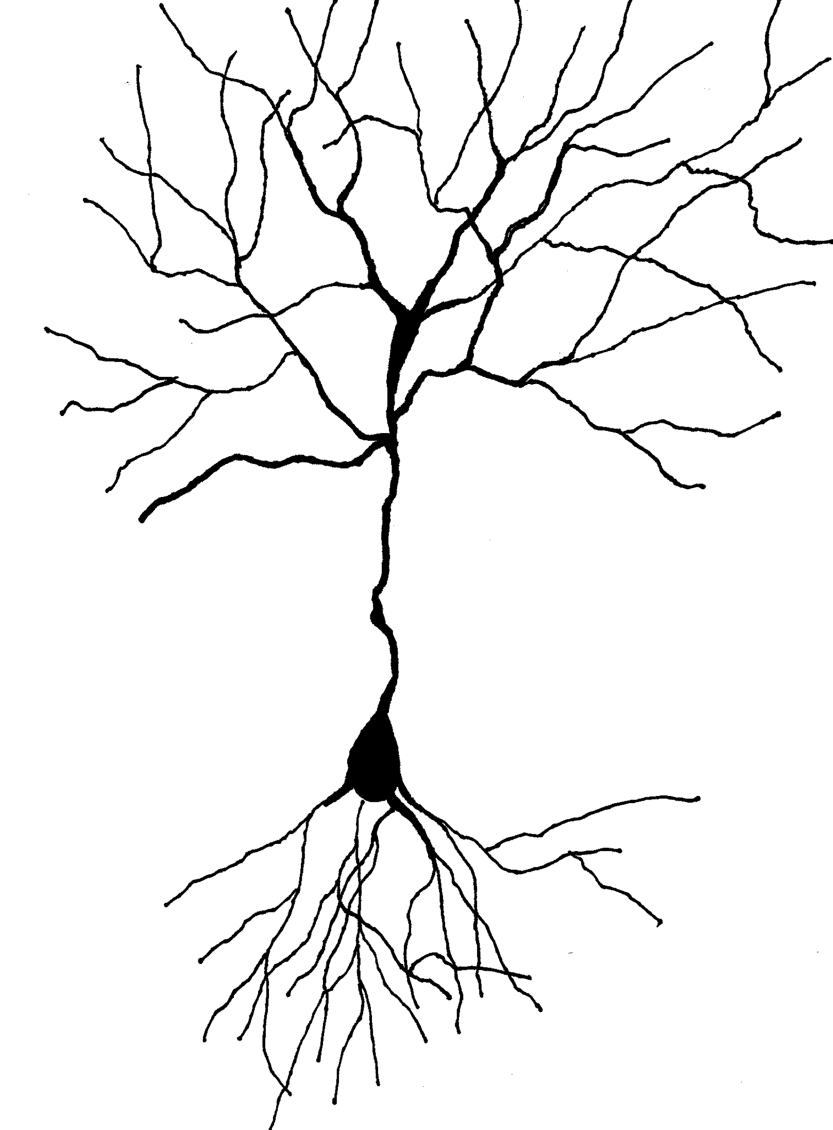  AIG  Referral Information  Chatham County Schools  Academically or Intellectually Gifted Program  2016-2019  www.chatham.k12.nc.us  Contact your school AIG specialist  for referral information.
Terms to know:  - Referral = nomination or presenting a student for evaluation  - Placement = actual entrance into the AIG program, requires parental consent  - Consent = permission to evaluate or serve  - Evaluation = series of data gathered for placement decision  - Criteria = qualifying data points  - Outside testing = completed by a licensed psychologist or psychiatrist with a school based focus  - Grade skipping = advancing ahead of the anticipated or current grade level  - Grade acceleration = advancing ahead of the anticipated or current grade level  - Differentiation = changing the curriculum to meet learner’s needs  - AIG specialist = a teacher at your child’s school who specializes and is trained in gifted education  - NDT = Needs Determination Team, AIG school based team  - CCSNDT = Chatham County Schools Needs Determination Team, makes final placement decisions  - CogAT = Cognitive Abilities Test  - Iowa = achievement test  - Portfolio = series of tasks  - Nurture = talent development  First Steps  The evaluation process is rigorous and requires time out of the classroom’s regular instruction. Students will be working with the AIG specialist and possibly an AIG specialist from |  | another school for the evaluation. Ask: Is your child ready for this? Can he/she miss classroom activities and be comfortable?  Next: consider the criteria in this brochure. Compare your child to the criteria. Use typical milestones for this. One example is an early reader isn’t necessarily gifted, but an early reader showing great comprehension might be. Talk with your classroom teacher or the AIG specialist objective input.  Ask: Does your child fit these criteria?  Now: get a referral form/permission to evaluate form from the office at your school or the AIG specialist. You can also download and print one from the website. Return this to your school’s specialist.  Second Graders  Only second grade transfer students who are identified in a previous school* are placed in the AIG program. Evaluation of students in the second grade invalidates test scores in the third grade. Third graders are screened and tested with tests that can only be administered once during a calendar year. Second graders are served by differentiation within the classroom.  Kindergarteners & First Graders  These students can be evaluated. Be aware that they may only be placed if they are Highly Gifted. Students in the HG range are exceptionally gifted and in the top 2% of all students academically. Some students are not ready for the evaluation process but are ready at third grade. It is exciting to watch them grow into success. |  | Pathway 1: Grades 3-12  Students must meet four criteria in reading or four in math to receive gifted education services in reading and/or math. Not all criteria must be included in evaluation. Students scoring at the 98th percentile on an accepted aptitude and/or achievement test and have one other criteria met are automatically placed in the AIG program as Highly Gifted in the area(s) of qualification. Highly Gifted in both math and reading places a student as AI. Additional data is not necessary for placement. In cases of acute circumstances or four criteria with <90th percentile on Aptitude or Achievement standardized testing,  one of the two test scores must be ≥75th percentile.  Available criteria include:  - ≥90th percentile Aptitude testing.  - ≥90th percentile Achievement testing.  - ≥90th percentile SMI testing may be used for math achievement as an example.  - ≥80% on AIG Portfolio scored on AIG rubric demonstrating work at least one grade level above the current grade level. (May be in native language or English.)  - Growth - Based on WIDA, a second language evaluation tool, scores as outlined from consultation with ESL Department.  - ≥90th percentile using accepted tests in areas outlined in this plan may be submitted by parents/guardians. These tests and reports must be conducted and written by a private, licensed psychologist or psychiatrist with a school related focus. The entirety of the report must be presented to the Needs Determination Team. Psychological reports must be submitted in full and will be considered in full for the best educational placement of the student. CCS is not responsible for providing outside testing.  - ≥80% on the AIG Specialist Inventory (based on multiple sources from current research).  - ≥80% on the Research Checklist for reading and/or math (currently the Scales for Rating the Behavioral Characteristics of Superior Students which is also known as Renzulli Scales).  - ≥80% on optional, student choice portfolio

